Spearman rank correlation: GBPUSD and NZDUSD
Method 02 / daily log returns / Alpari D1 full available history

Study setup
Logical pair: GBPUSD , NZDUSD
Broker symbols: GBPUSD_i , NZDUSD_i
Snapshot: 2026-11-03_majors_alpari_D1
Timeframe: D1
Matched return window: 1999-01-05 to 2026-11-02 (UTC bar dates)
Matched return count n: 7203
Dropped unfinished last bar dated 2026-11-03 UTC after a tick-volume check against the prior complete day.
Complete matched rows (CSV): GBPUSD-NZDUSD_Spearman_D1.csv
Complete matched rows (HTML table): GBPUSD-NZDUSD_Spearman_D1_data.html

Method carried forward
Spearman rho is Pearson correlation on the ranks of matched daily log returns of close, ln(close_t / close_t-1), in the broker quote direction. Ties use average ranks. Quotes are not inverted. rho is symmetric under swap of the two symbols. rho = 0 means no consistent rank-order link in this sample; it does not mean no link of any kind. The score is not a cause, not a lead, and not a trading signal. Daily rows are not independent draws, so the two-sided p-value and approximate Fisher interval are reported and treated as secondary to rho. Same-sample Pearson r is shown only as a side check; a large rho minus r gap can flag outliers or a non-straight link.

Results
Spearman rho: 0.500616
Two-sided p-value: 0
Approximate 95% Fisher interval: [0.483107, 0.517724]
Same-sample Pearson r: 0.530079
rho minus r: -0.029463

Conclusion
Over 7203 matched daily log-return rows for GBPUSD and NZDUSD (broker quote directions unchanged), Spearman rho is 0.5006 (positive, moderate rank-order association in this sample). Approximate 95% Fisher interval: [0.4831, 0.5177]. Same-sample Pearson r is 0.5301 (rho minus r = -0.0295). Two-sided p under the usual independent-ranks model is 0; that model does not match linked daily FX returns, so treat p as secondary. This does not establish cause, lead-lag, or a lasting trading rule.

Charts
Daily closes

Daily log returns
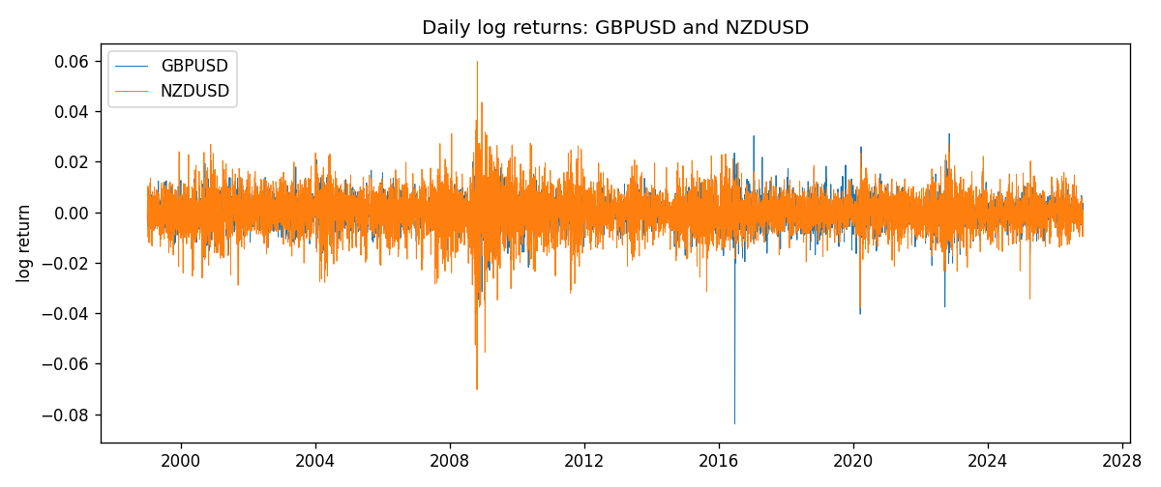
Log-return scatter
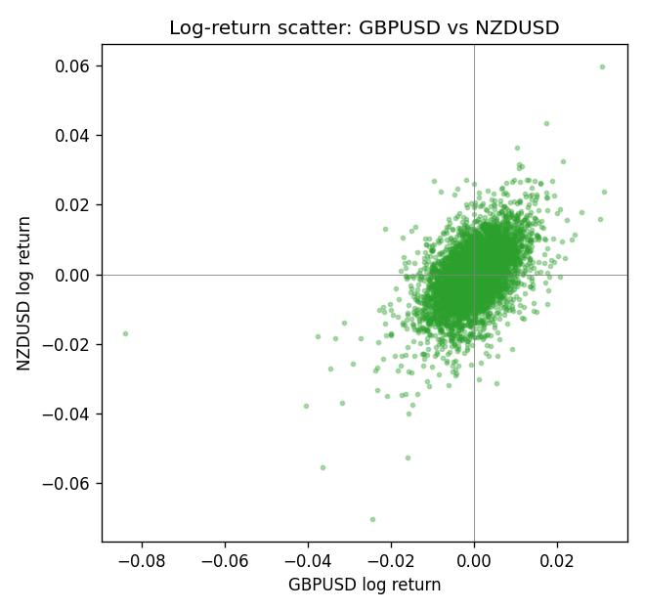
Rank-rank scatter
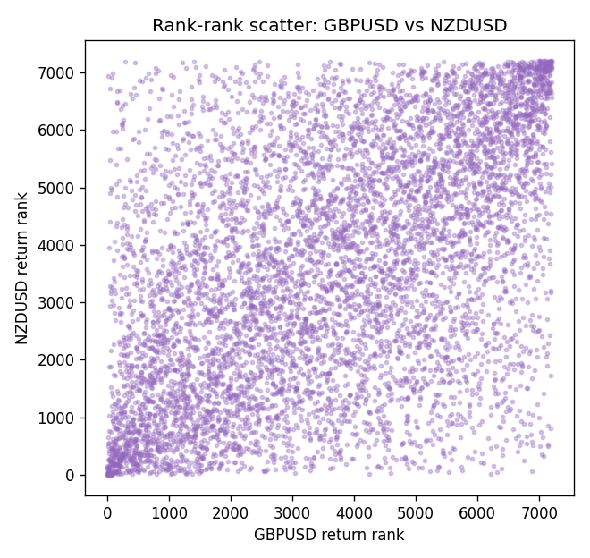

Data report
Every matched row that entered Spearman rho is stored in the sibling CSV named GBPUSD-NZDUSD_Spearman_D1.csv. That file is the complete data archive for redrawing charts. Embedding all rows as a Word table is impractical at this length; the Word file holds the column list, column summaries, and the first and last 15 matched rows.
Columns: time, GBPUSD_open, NZDUSD_open, GBPUSD_high, NZDUSD_high, GBPUSD_low, NZDUSD_low, GBPUSD_close, NZDUSD_close, GBPUSD_tick_volume, NZDUSD_tick_volume, GBPUSD_spread, NZDUSD_spread, GBPUSD_real_volume, NZDUSD_real_volume, GBPUSD_log_return, NZDUSD_log_return
Column summaries (matched calculation rows)
column | count | mean | std | min | 25% | 50% | 75% | max
GBPUSD_open | 7203 | 1.5160351 | 0.21820856 | 1.06854 | 1.32502 | 1.51126 | 1.63163 | 2.1066
NZDUSD_open | 7203 | 0.65617721 | 0.10827592 | 0.3913 | 0.59107 | 0.6683 | 0.72469 | 0.88218
GBPUSD_high | 7203 | 1.5223294 | 0.21877071 | 1.08366 | 1.3298 | 1.51797 | 1.63833 | 2.1161
NZDUSD_high | 7203 | 0.66009189 | 0.10877133 | 0.3961 | 0.594565 | 0.67188 | 0.729235 | 0.88421
GBPUSD_low | 7203 | 1.5097156 | 0.21743942 | 1.03518 | 1.319525 | 1.50315 | 1.62431 | 2.0983
NZDUSD_low | 7203 | 0.65248767 | 0.1078698 | 0.3897 | 0.587935 | 0.66402 | 0.72082 | 0.87988
GBPUSD_close | 7203 | 1.5161019 | 0.21816437 | 1.06879 | 1.32515 | 1.51122 | 1.63196 | 2.1065
NZDUSD_close | 7203 | 0.65624807 | 0.10827144 | 0.3907 | 0.591395 | 0.6683 | 0.724915 | 0.8822
GBPUSD_tick_volume | 7203 | 94800.961 | 153533.35 | 62 | 9991 | 52873 | 91772.5 | 1273370
NZDUSD_tick_volume | 7203 | 68552.383 | 123030.52 | 16 | 5500.5 | 33815 | 58467.5 | 1127682
GBPUSD_spread | 7203 | 26.976121 | 19.194852 | 0 | 11 | 20 | 50 | 50
NZDUSD_spread | 7203 | 30.373178 | 25.676979 | 0 | 9 | 17 | 50 | 80
GBPUSD_real_volume | 7203 | 3.5551025e+09 | 8.4426509e+10 | 0 | 0 | 0 | 0 | 2.4038164e+12
NZDUSD_real_volume | 7203 | 1.6657093e+10 | 8.4881524e+10 | 0 | 0 | 0 | 0 | 2.705649e+12
GBPUSD_log_return | 7203 | -2.372e-05 | 0.00564203 | -0.08388241 | -0.00312422 | 3.221e-05 | 0.0031735 | 0.03112653
NZDUSD_log_return | 7203 | 5.29e-06 | 0.00764545 | -0.07027433 | -0.00426254 | 0.00021291 | 0.00457891 | 0.05966839
First 15 matched rows (selected columns)
time | GBPUSD_close | NZDUSD_close | GBPUSD_log_return | NZDUSD_log_return | GBPUSD_tick_volume | NZDUSD_tick_volume
1999-01-05 | 1.6547 | 0.5372 | -0.0028966287 | -0.0018597736 | 4645 | 748
1999-01-06 | 1.6537 | 0.5383 | -0.00060452184 | 0.0020455609 | 4729 | 823
1999-01-07 | 1.6502 | 0.5417 | -0.002118709 | 0.0062963171 | 4858 | 878
1999-01-08 | 1.6405 | 0.5414 | -0.0058954193 | -0.00055396548 | 5354 | 668
1999-01-11 | 1.6312 | 0.547 | -0.0056851331 | 0.010290425 | 4080 | 681
1999-01-12 | 1.6349 | 0.5441 | 0.0022657001 | -0.0053157489 | 5001 | 793
1999-01-13 | 1.6499 | 0.5387 | 0.0091330396 | -0.0099742238 | 5730 | 1050
1999-01-14 | 1.6531 | 0.5386 | 0.0019376331 | -0.00018564931 | 4902 | 1137
1999-01-15 | 1.6502 | 0.5382 | -0.0017558204 | -0.00074294208 | 6383 | 1124
1999-01-18 | 1.6522 | 0.5372 | 0.0012112405 | -0.0018597736 | 4357 | 1022
1999-01-19 | 1.6553 | 0.5382 | 0.0018745281 | 0.0018597736 | 4655 | 1389
1999-01-20 | 1.6472 | 0.5404 | -0.0049053846 | 0.0040793678 | 4502 | 1678
1999-01-21 | 1.6524 | 0.5426 | 0.0031518998 | 0.0040627941 | 4609 | 1599
1999-01-22 | 1.6565 | 0.5361 | 0.0024781662 | -0.012051689 | 4230 | 1328
1999-01-25 | 1.6585 | 0.5342 | 0.0012066366 | -0.0035504102 | 3069 | 1035
Last 15 matched rows (selected columns)
time | GBPUSD_close | NZDUSD_close | GBPUSD_log_return | NZDUSD_log_return | GBPUSD_tick_volume | NZDUSD_tick_volume
2026-10-13 | 1.32534 | 0.56127 | 0.0036434319 | 0.0047326165 | 53930 | 27958
2026-10-14 | 1.31884 | 0.55918 | -0.0049164679 | -0.0037306483 | 64640 | 37319
2026-10-15 | 1.32757 | 0.56185 | 0.0065976411 | 0.0047634855 | 80461 | 43714
2026-10-16 | 1.33257 | 0.56509 | 0.0037592051 | 0.0057501001 | 65988 | 35806
2026-10-19 | 1.33024 | 0.56616 | -0.0017500314 | 0.0018917133 | 56543 | 32069
2026-10-20 | 1.3377 | 0.56827 | 0.0055923442 | 0.0037199341 | 58955 | 34470
2026-10-21 | 1.33937 | 0.57003 | 0.0012476328 | 0.0030923331 | 55613 | 30020
2026-10-22 | 1.33967 | 0.56815 | 0.00022396082 | -0.0033035227 | 64255 | 39159
2026-10-23 | 1.33684 | 0.56991 | -0.0021146949 | 0.0030929853 | 58068 | 33693
2026-10-26 | 1.33359 | 0.56826 | -0.0024340661 | -0.0028993932 | 56434 | 30716
2026-10-27 | 1.33044 | 0.56811 | -0.0023648393 | -0.00026399852 | 54846 | 32660
2026-10-28 | 1.33254 | 0.56261 | 0.0015771808 | -0.0097283914 | 61264 | 42740
2026-10-29 | 1.33733 | 0.56296 | 0.0035881935 | 0.00062190714 | 71194 | 40247
2026-10-30 | 1.33913 | 0.56307 | 0.0013450605 | 0.00019537668 | 70446 | 39305
2026-11-02 | 1.3406 | 0.56161 | 0.0010971256 | -0.0025962955 | 60471 | 35347

